
CSA05-DATABASE MANAGEMENT SYSTEMS

AIM
To perform JOIN using Equi Join, Inner Join, Outer Join on the given relation.

DESCRIPTION
A JOIN combines rows from two or more tables using a related column. Equi Join uses an equality condition. INNER JOIN returns matching records from both tables. LEFT JOIN returns all records from the left table and matching records from the right table. RIGHT JOIN returns all records from the right table and matching records from the left table.

1. Select Database
USE collegedb;
OUTPUT:

2. Create CoffeeCategory Table
CREATE TABLE CoffeeCategory (
CategoryID INT PRIMARY KEY,
CategoryName VARCHAR(30),
Type VARCHAR(20)
);
OUTPUT:
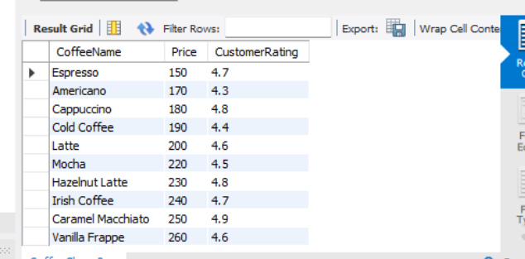

3. Insert Category Records
INSERT INTO CoffeeCategory VALUES
(1, 'Hot Coffee', 'Hot'),
(2, 'Cold Coffee', 'Cold'),
(3, 'Espresso', 'Hot'),
(4, 'Specialty', 'Special');
OUTPUT:
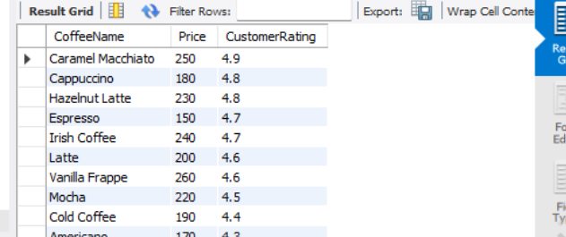

4. Display CoffeeCategory Records
SELECT * FROM CoffeeCategory;
OUTPUT:
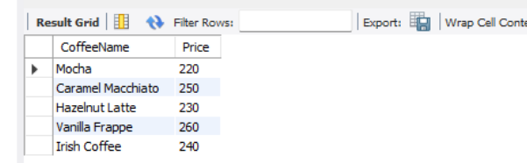

5. Display Existing CoffeeShop Records
SELECT * FROM CoffeeShop;
OUTPUT:
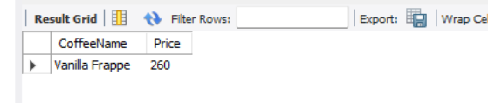

6. Add CategoryID to CoffeeShop
ALTER TABLE CoffeeShop ADD CategoryID INT;
OUTPUT:
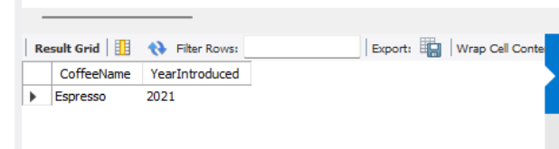

7. Assign Category IDs
UPDATE CoffeeShop
SET CategoryID = CASE
WHEN CoffeeName IN ('Cappuccino', 'Cafe Latte', 'Espresso') THEN 1
WHEN CoffeeName = 'Cold Coffee' THEN 2
WHEN CoffeeName = 'Americano' THEN 3
ELSE 4
END;
OUTPUT:


8. Verify CategoryID
SELECT CoffeeName, CategoryID FROM CoffeeShop;
OUTPUT:
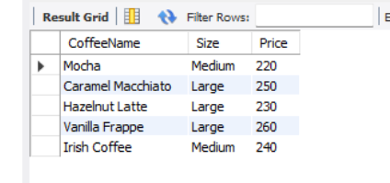

9. Equi Join
SELECT c.CoffeeName, c.Price, cat.CategoryName, cat.Type
FROM CoffeeShop c, CoffeeCategory cat
WHERE c.CategoryID = cat.CategoryID;
OUTPUT:


10. Inner Join
SELECT c.CoffeeName, c.Price, cat.CategoryName, cat.Type
FROM CoffeeShop c
INNER JOIN CoffeeCategory cat ON c.CategoryID = cat.CategoryID;
OUTPUT:
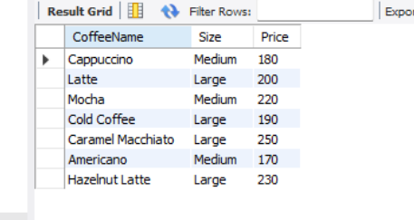

11. Left Outer Join
SELECT c.CoffeeName, c.Price, cat.CategoryName, cat.Type
FROM CoffeeShop c
LEFT JOIN CoffeeCategory cat ON c.CategoryID = cat.CategoryID;
OUTPUT:


12. Right Outer Join
SELECT c.CoffeeName, c.Price, cat.CategoryName, cat.Type
FROM CoffeeShop c
RIGHT JOIN CoffeeCategory cat ON c.CategoryID = cat.CategoryID;
OUTPUT:


13. Cross Join (if required)
SELECT c.CoffeeName, cat.CategoryName
FROM CoffeeShop c
CROSS JOIN CoffeeCategory cat;
OUTPUT:
Screenshot:
____________________________________________________________

RESULT
Thus, JOIN operations including Equi Join, Inner Join, Left Outer Join and Right Outer Join were successfully performed using the CoffeeShop and CoffeeCategory relations.

